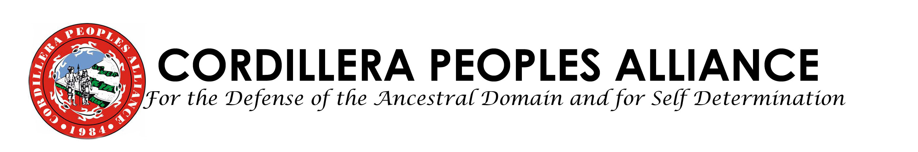

FOR IMMEDIATE RELEASE

October 12, 2009

Relief, Retrieval and Medical Missions Sought in Cordillera; Many Communities Still Inaccessible

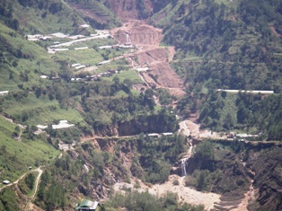
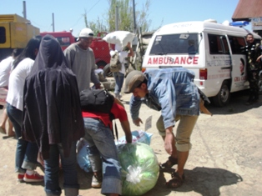
BAGUIO CITY—Monitoring and documentation from the Serve the People Brigade Cordillera Disaster Response Network yesterday and this morning state that many of the Baguio and Benguet communities and families still need relief, clearing, retrieval and medical missions. For October 11, the Brigade rendered clearing and relief missions in Pinsao and Fairview, benefiting 160 families; and 60 families in Sto, Niño, Acop, Tublay. Fuel is now being rationed in Baguio City. As of presstime 265 deaths were documented in the Cordillera.
Landslide in Ambassador, Tublay. Below: Brigade volunteers unloading relief goods.

Massive landslides have made Kilometers 16 to 35 in Tublay, Benguet province impassable, such that access to the communities to deliver the relief services is limited. Heavy equipment is needed to clear the roads. As per report of the monitoring and documentation teams, relief, medical and retrieval missions are much needed in Tublay. Other donors, organizations and institutions are requested to channel some of their services here. Sixty families benefited from the Brigade’s relief and medical services yesterday Pontino, Ambassador, Tublay, Benguet. In the relief and clearing missions today in Pontino, around 107 families were given relief and medical services. Documentors noted 12 dead in Sto. Niño with 2 still missing; 10 houses were destroyed in Sition Sapuan; 45 families from Sto. Niño have been evacuated into the Pontino Elem. School. The evacuees need medicine, tents, food supplies, toiletries, water, water containers, mats and blankets.

As of evening of October 11, 28 bodies were recovered in Guinaoang, Mankayan while 17 families were evacuated into safer grounds from the sinking area of Poblacion. Cracks were meanwhile noticed from the landing strip in Pukitan also in Mankayan. In another mining-ravaged town, Itogon, 1 body was retrieved today in Gumatdang while families were reported affected by the slides in DalicnoThe Brigade provided food for work for the retrieval team in Gumatdang.

Today in Baguio, the Brigade dispatched a team for ocular inspection at Purok 1, Irisan, and it was determined that 150 families are needing relief and rescue missions. Monitoring, documentation and relief missions were also carried out in the evacuation centers of St. Vincent Gym, City Camp Barangay Hall, Irisan (Cypress and Marville), Bakakeng Central in Kitma. The Office of Civil Defense in Baguio reports that 476 families or 1, 850 individuals are now in evacuation centers; 57 dead, 5 missing and 27 injured.
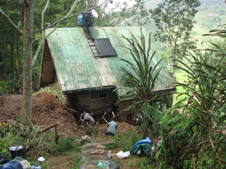
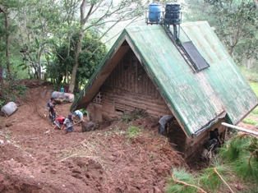
In La Trinidad, monitoring and documentation was carried out in Buyagan—along the La Trinidad Central School and Cordillera Career Development College. The number of retrieved bodies in Puguis has reached 67.

In an interview with Gov. Teddy Baguilat of Ifugao province, the estimated cost of damages for infrastructure is P110 million while damages crops are estimated at P90 million worth. One was reported dead in Aguinaldo. Some 5 victims in Baguio, who hail from Mayaoyao and Hungduan municipalities, were already brought home. Bridges in Lamut, Tinoc, Mayaoyao nad Hungduan were washed out.

In Tadian, Mountain Province, 6 more bodies were recovered in Kayan East today. The retrieval operations are still ongoing.

The local government unit of Abra meanwhile estimates around 90 million worth of infrastructure damaged in the province. KASTAN CPA Abra is still gathering data in the upland municipalities.

The Serve the People Brigade will hold relief and rescue operations in Itogon and Mankayan in the coming week. Please visit us at No. 55 Ferguson Road, Brgy. A. Bonifacio, Baguio City and look for Mr. Santos Mero, Serve the People Brigade Coordinator and CPA Deputy Secretary General (09152054262) to donate and volunteer. You may also call or text the Hotline at mobile number 09209286370 or Telephone Number 63- 074-304-4239, Fax number is 63-074-443-7159. You can also reach us through email at cpa@cpaphils.org for queries. # With reports from CPA Mountain Province, MAQUITACDG, Itogon Inter Barangay Alliance, Save Apayao People’s Organization and KASTAN CPA Abra.
Clearing operations in Ambiong, La Trinidad, Benguet

SERVE THE PEOPLE BRIGADE -CORDILLERA DISASTER RESPONSE NETWORK
Cordillera Peoples Alliance
Center for Development Programs in the Cordillera
Serve the People Brigade-Cordillera Disaster Response Center sincerely thanks the following organizations and individuals who have donated and volunteered for the relief, rescue and medical missions:

Lales Family, Chua Family, Nalisa Family, Bayanihan 4th Floor, Reporma-SLU, Karen Kelley, Khalil Rapisura, UC Students, Razel, SLU Ambiong, Reporma-ACS, various SLU students, Jan Mark, Stable, Olga Joy, Kappa Epsilon, Mary Knoll Convent through Sr. Margarita, De Guzman Drugstore, Aurora Hill Residents, Ador Ramo, Mrs. Dominga Cayat, Kalasag-UC, Cordillera Disaster Response-RDS, Luchie Maranan, Donna Villamor, Elsie Moyaen Bautista, Dr. Olowan, Makoy, SLU Medical Students, UP Baguio Outcrop, Unknown taxi driver, Macalanda Family, Mia Rasalan, Dr. Ana Leung, Filer Family, Dr. JP Leung, Microtel Hotel, CWEARC, Baguio Skateboarding Crew, Luchi Ofo-ob, Mark Adviento, Marcelino Benito, Jay Pinera, Carmen Bolinto, Co Family, Baby Co, City Tavern, PNA through Dr. Caster Palaganas, Sultan Review Center, Mr. Rob Ocampo, Café by the Ruins, Chie Galvez, Elegant Washers, Cora Loste, Maranan Family, Aris Family, RDC-KADUAMI, Bestang Dekdeken, Cynthia Dacanay, ABS CBN

